**Name: Eze O. Amadi**

**SQL Assignment**

Comp 5400

Due Date: March 22, 2021

**PART I**

1. Selecting everything from the employees table.

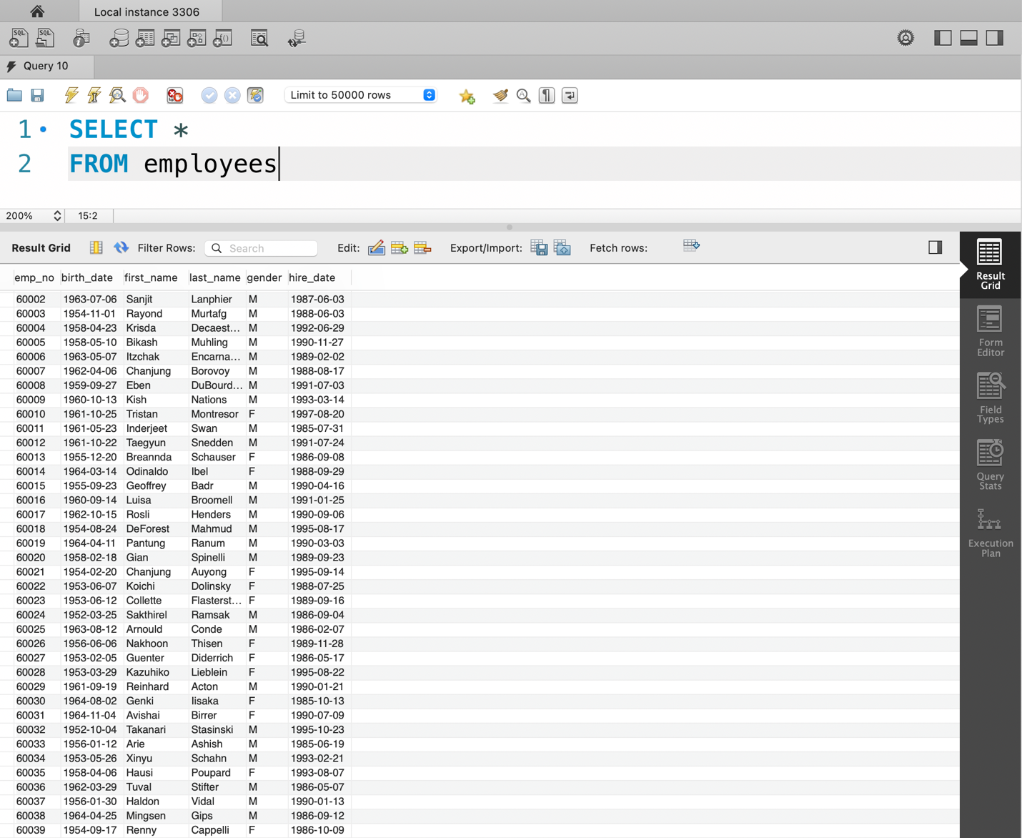

1. Selecting 3 columns – dept_no, from_date and to_date from the dept_manager table.

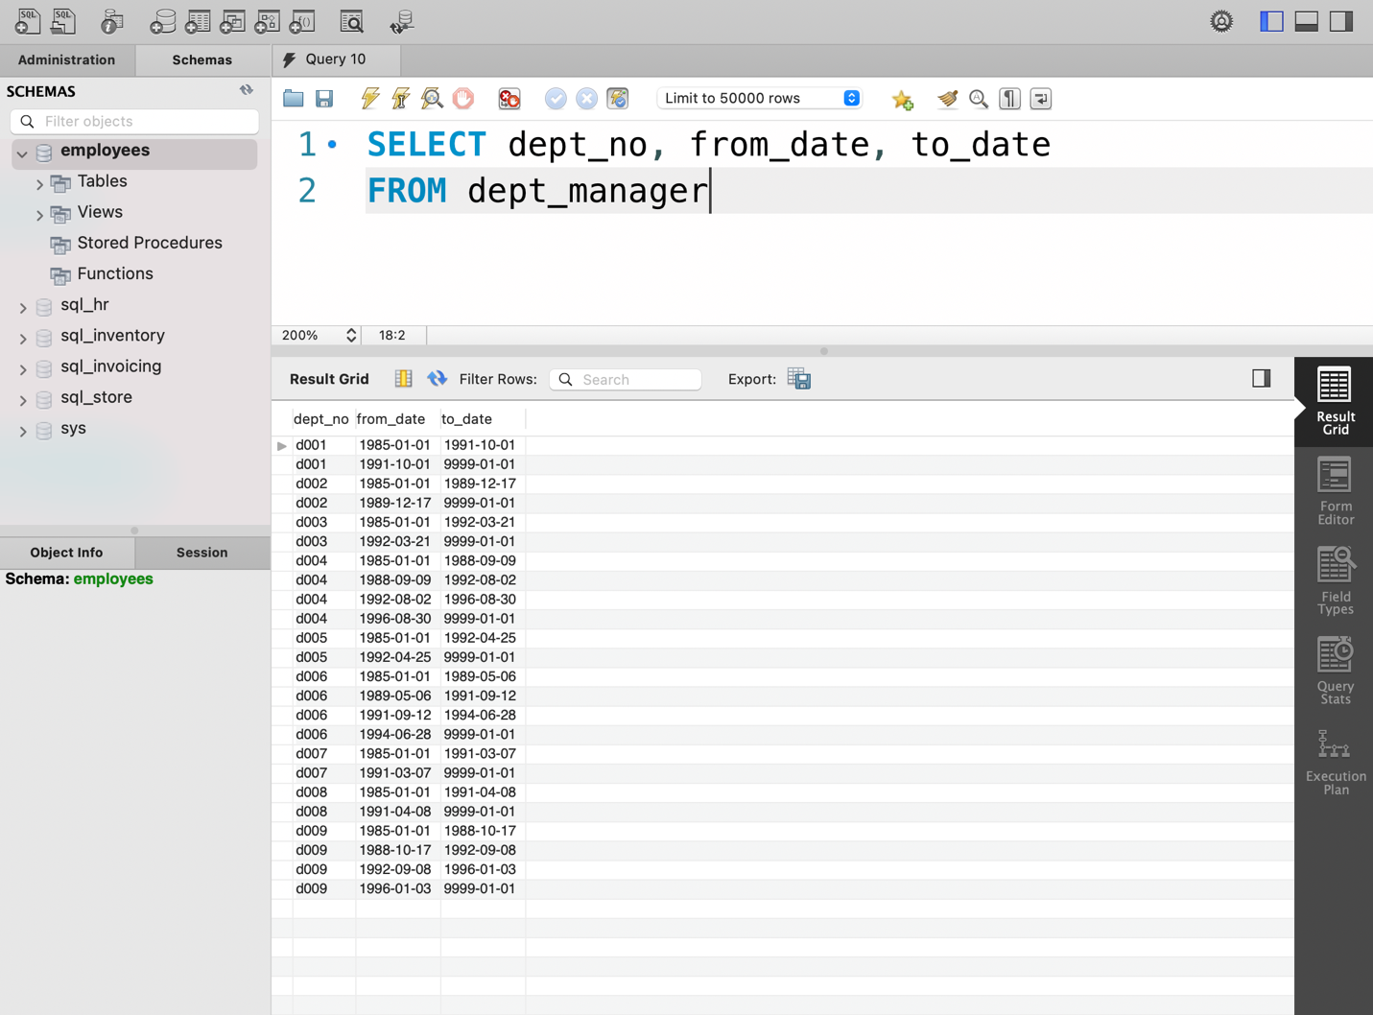

1. Selecting first name and last name of employees born on or before January 1st, 1960.

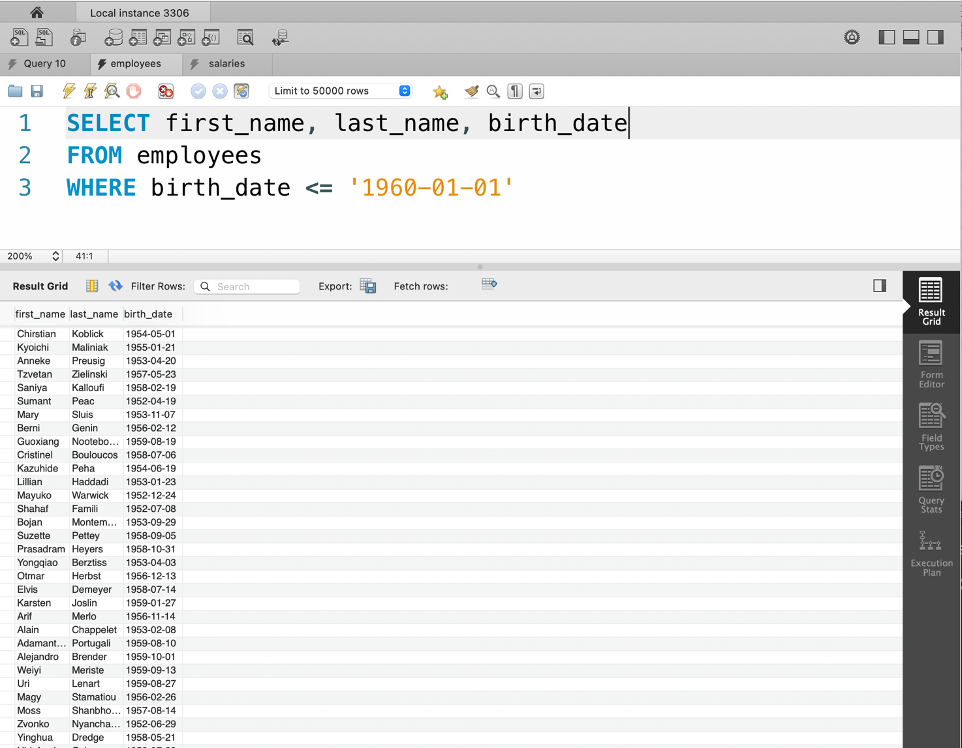

1. Display all the information of female employees who were born before January 1st 1960 or hired after January 1st 1970 .

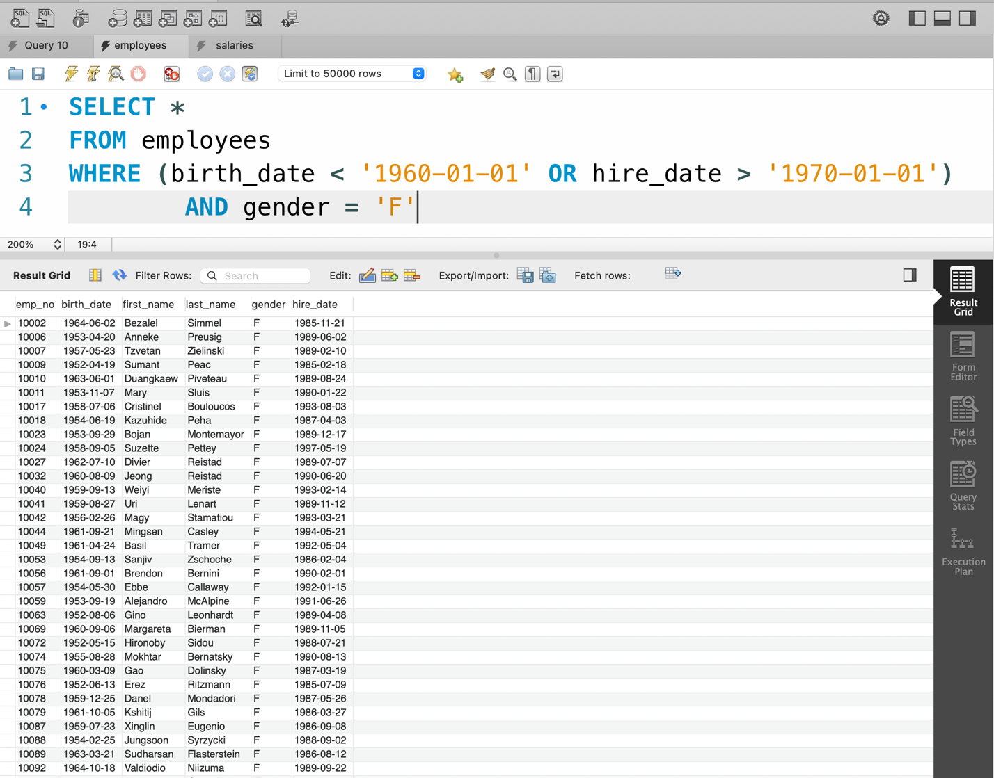

1. Rename the dept_no and dept_name columns appropriately in the departments table.

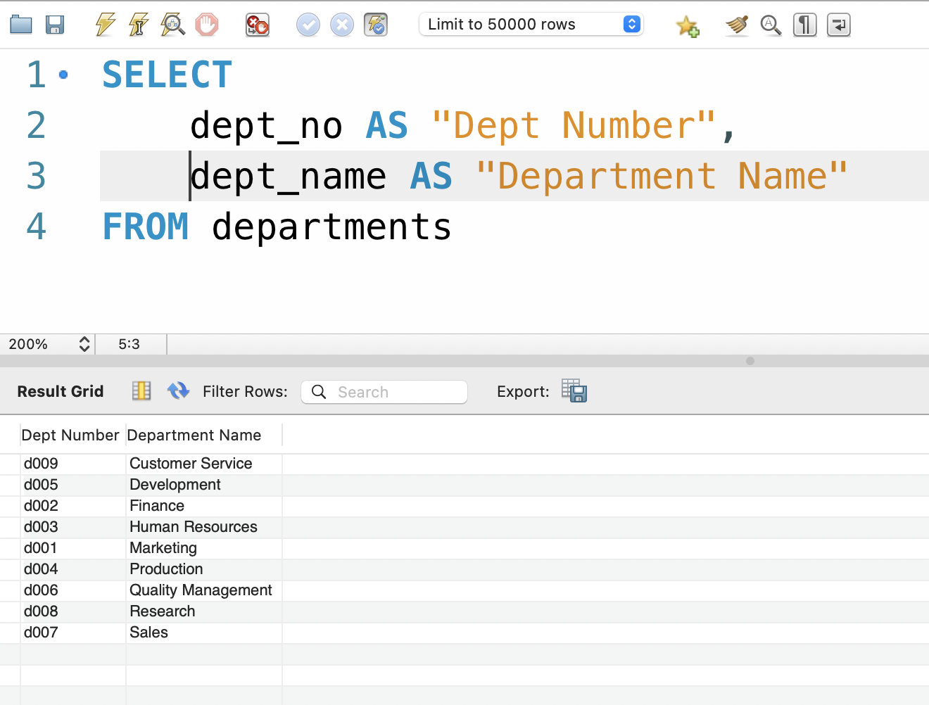

1. Display concatenated full names of employees hired after January 1st, 2000.

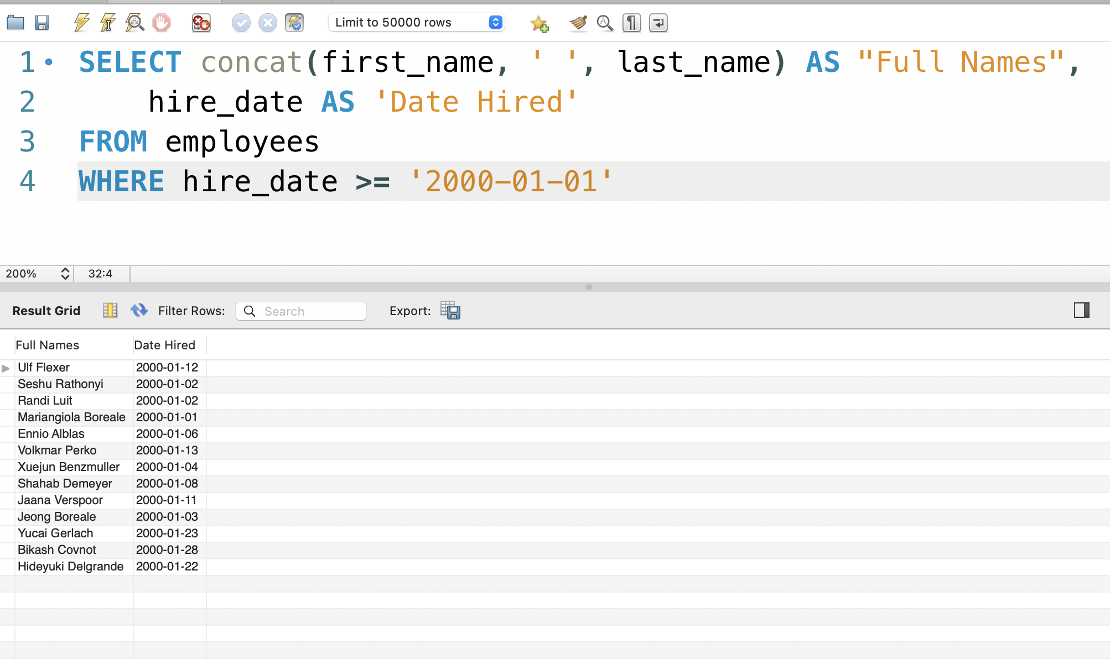

1. Display the full names of employees and assign them their generation names according to their birth dates.

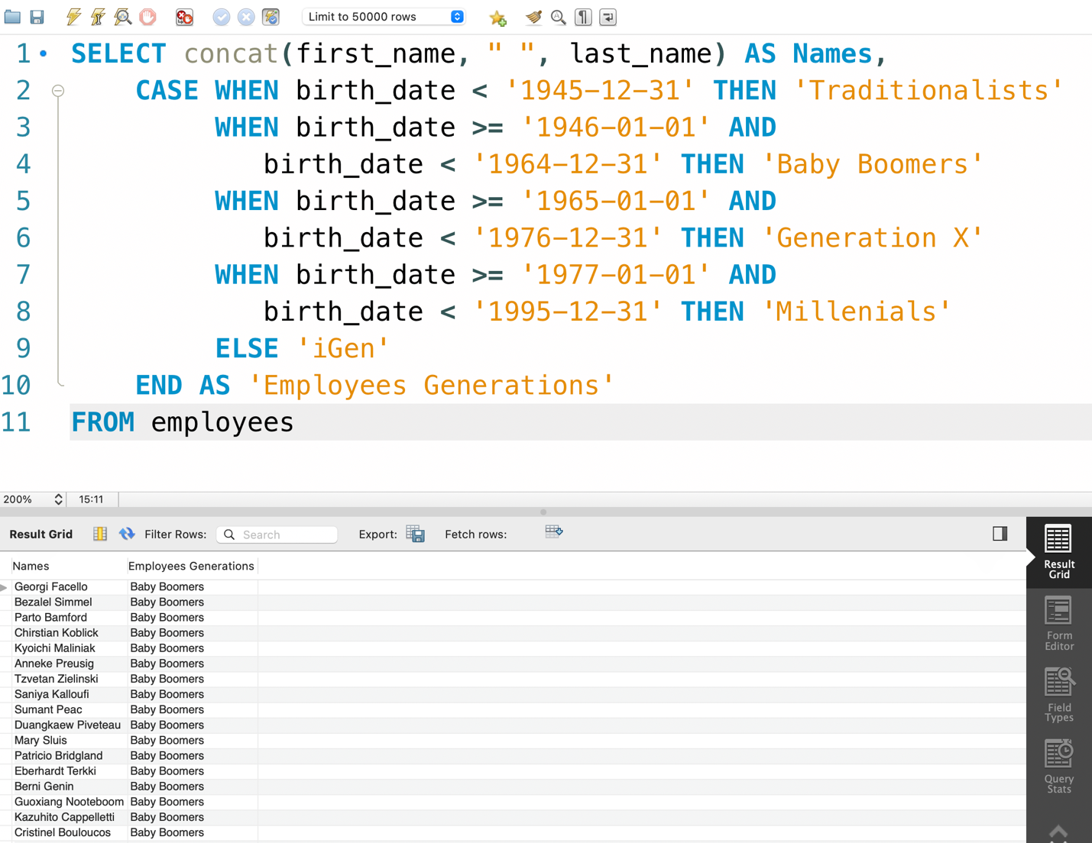

1. Display the first 30 entries in the salary table 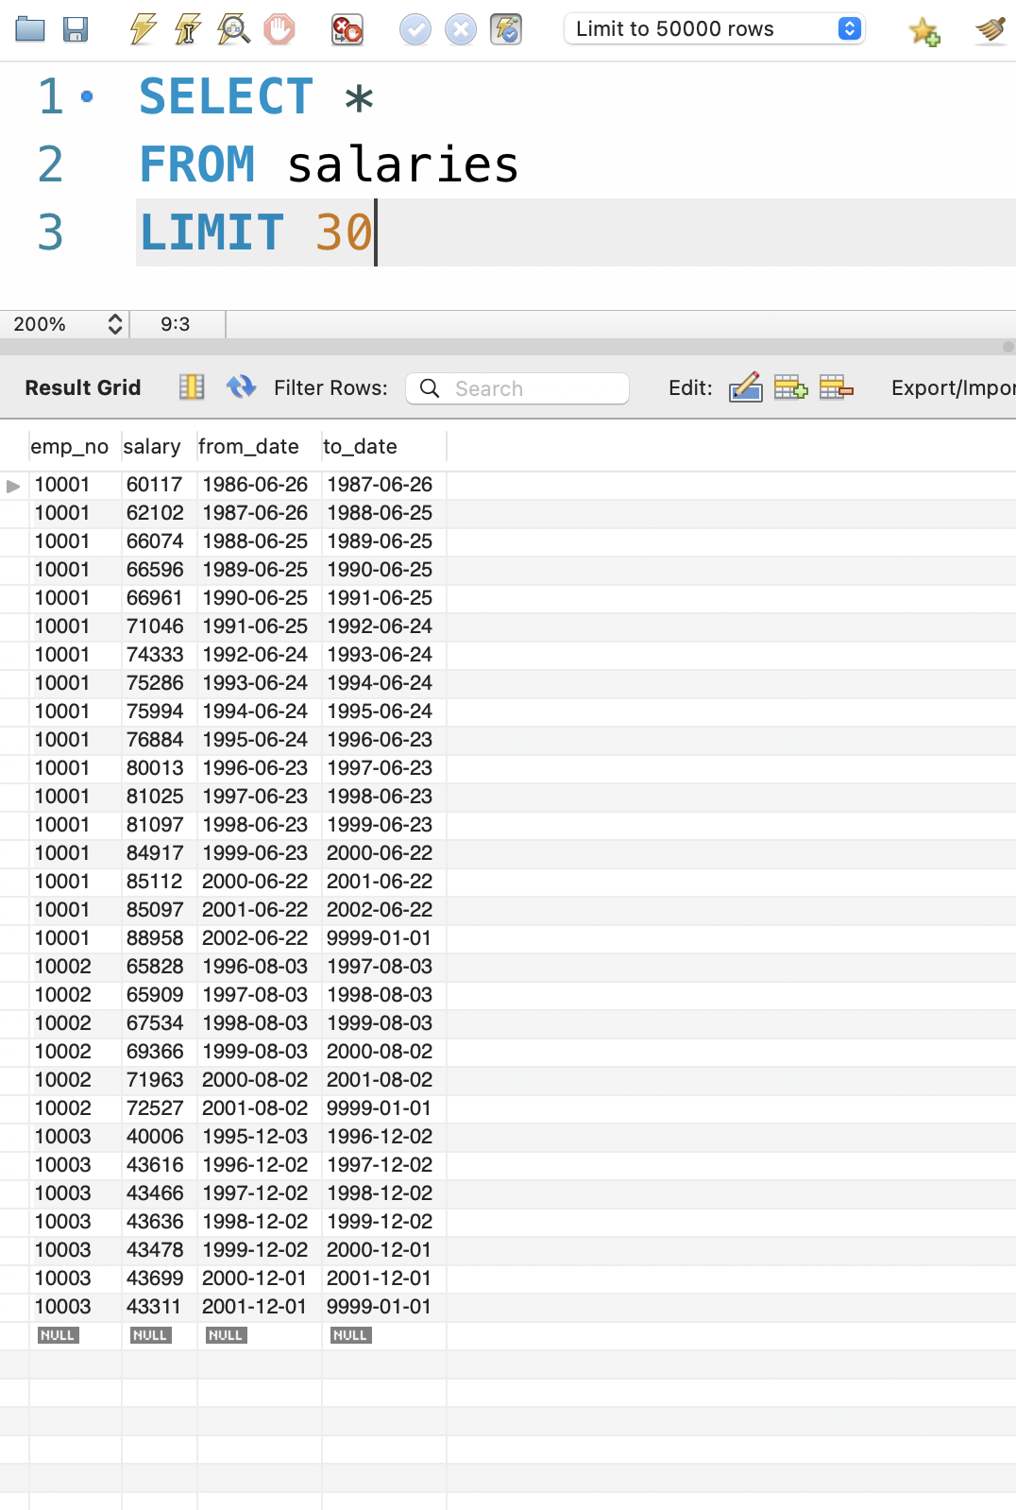
2. Display 10 random records from the dept_emp table.

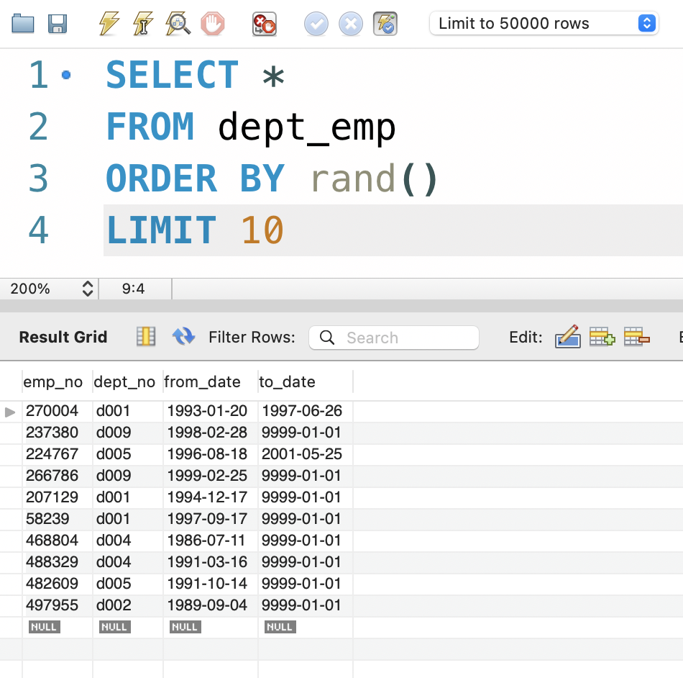

1. Display all entries with null values in the titles table.

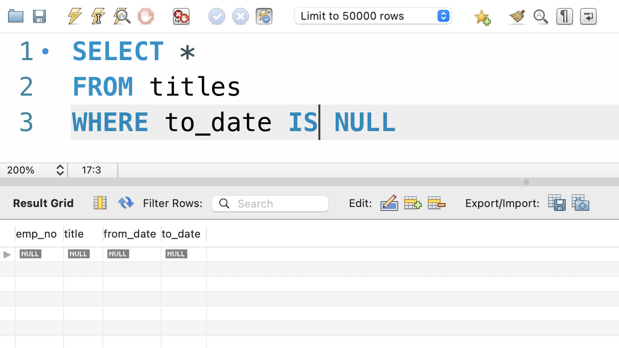

1. Replace the birth_dates entries that have null values, if any, in the employees table with 0.

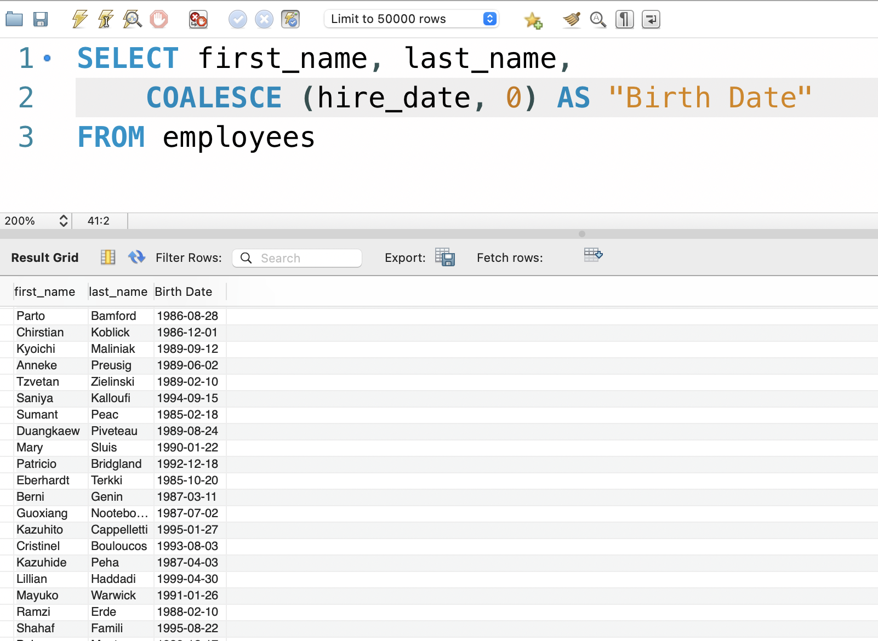

1. Use the “IN” operator to display employees that have last names Bamford or Erde.

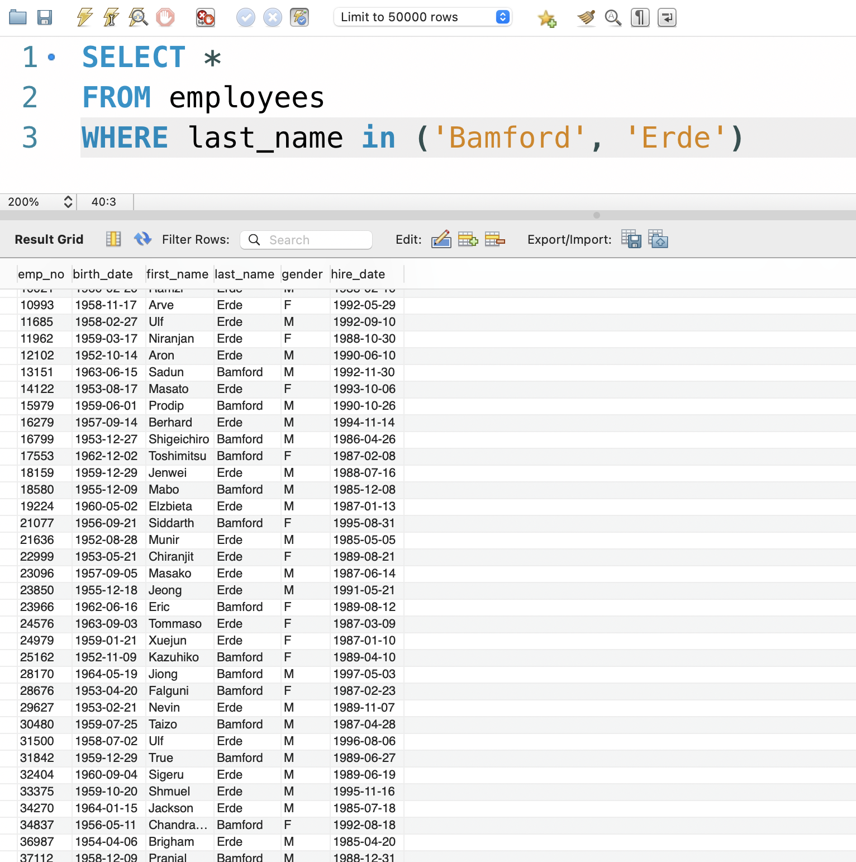

1. Display the list of employees with last name Bamford or Erde and first names that either contains ‘fr’ (together) or ‘t’ and ‘h’.

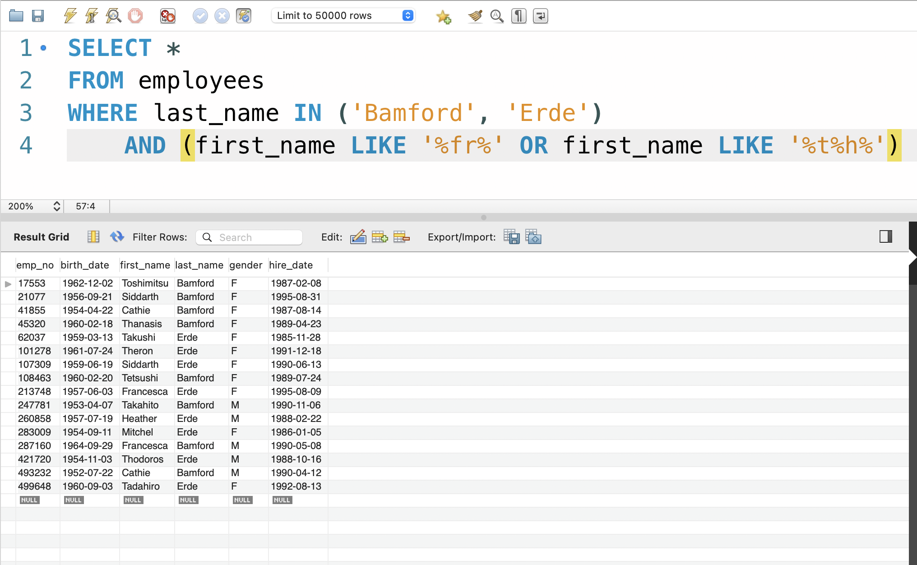

**PART II**

1. Display a list of male employees with last name Terkki and sort list by their first names.

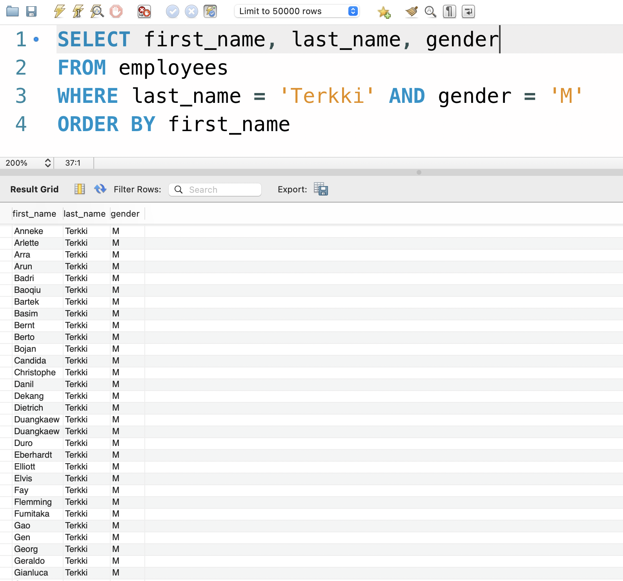

1. Display a list of male employees with last name Terkki and sort list by their birth dates first and then their first name in descending order.

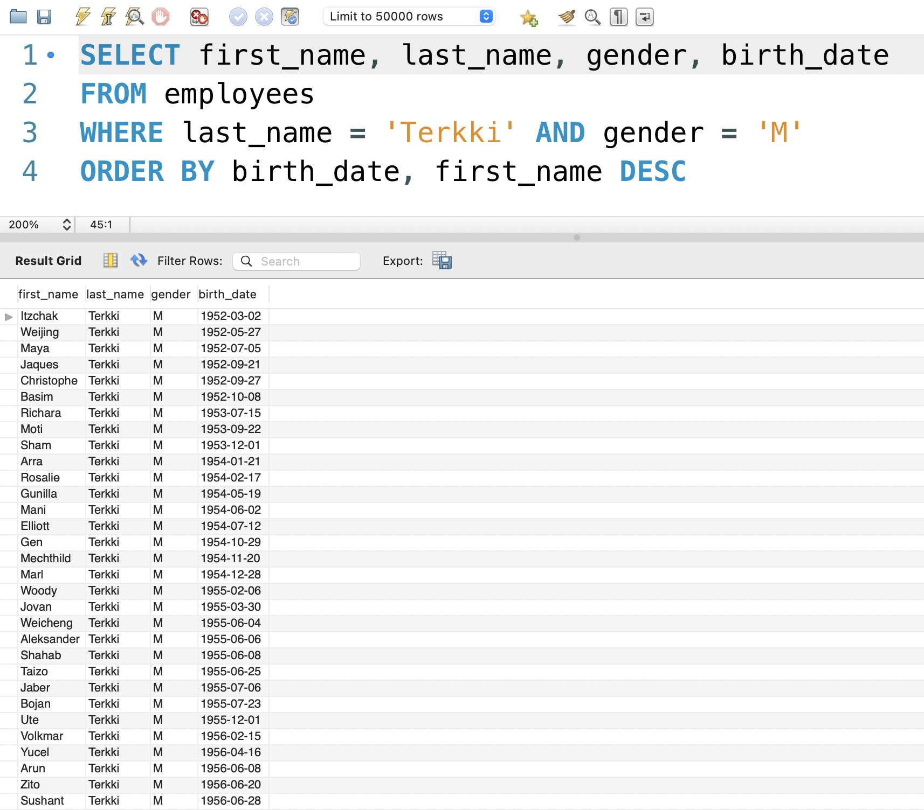

1. Displaying a list of employees whose first names contain ‘fro’ and last names has a ‘c’ in them. The list is sorted alphabetically from the third letter in the first names.

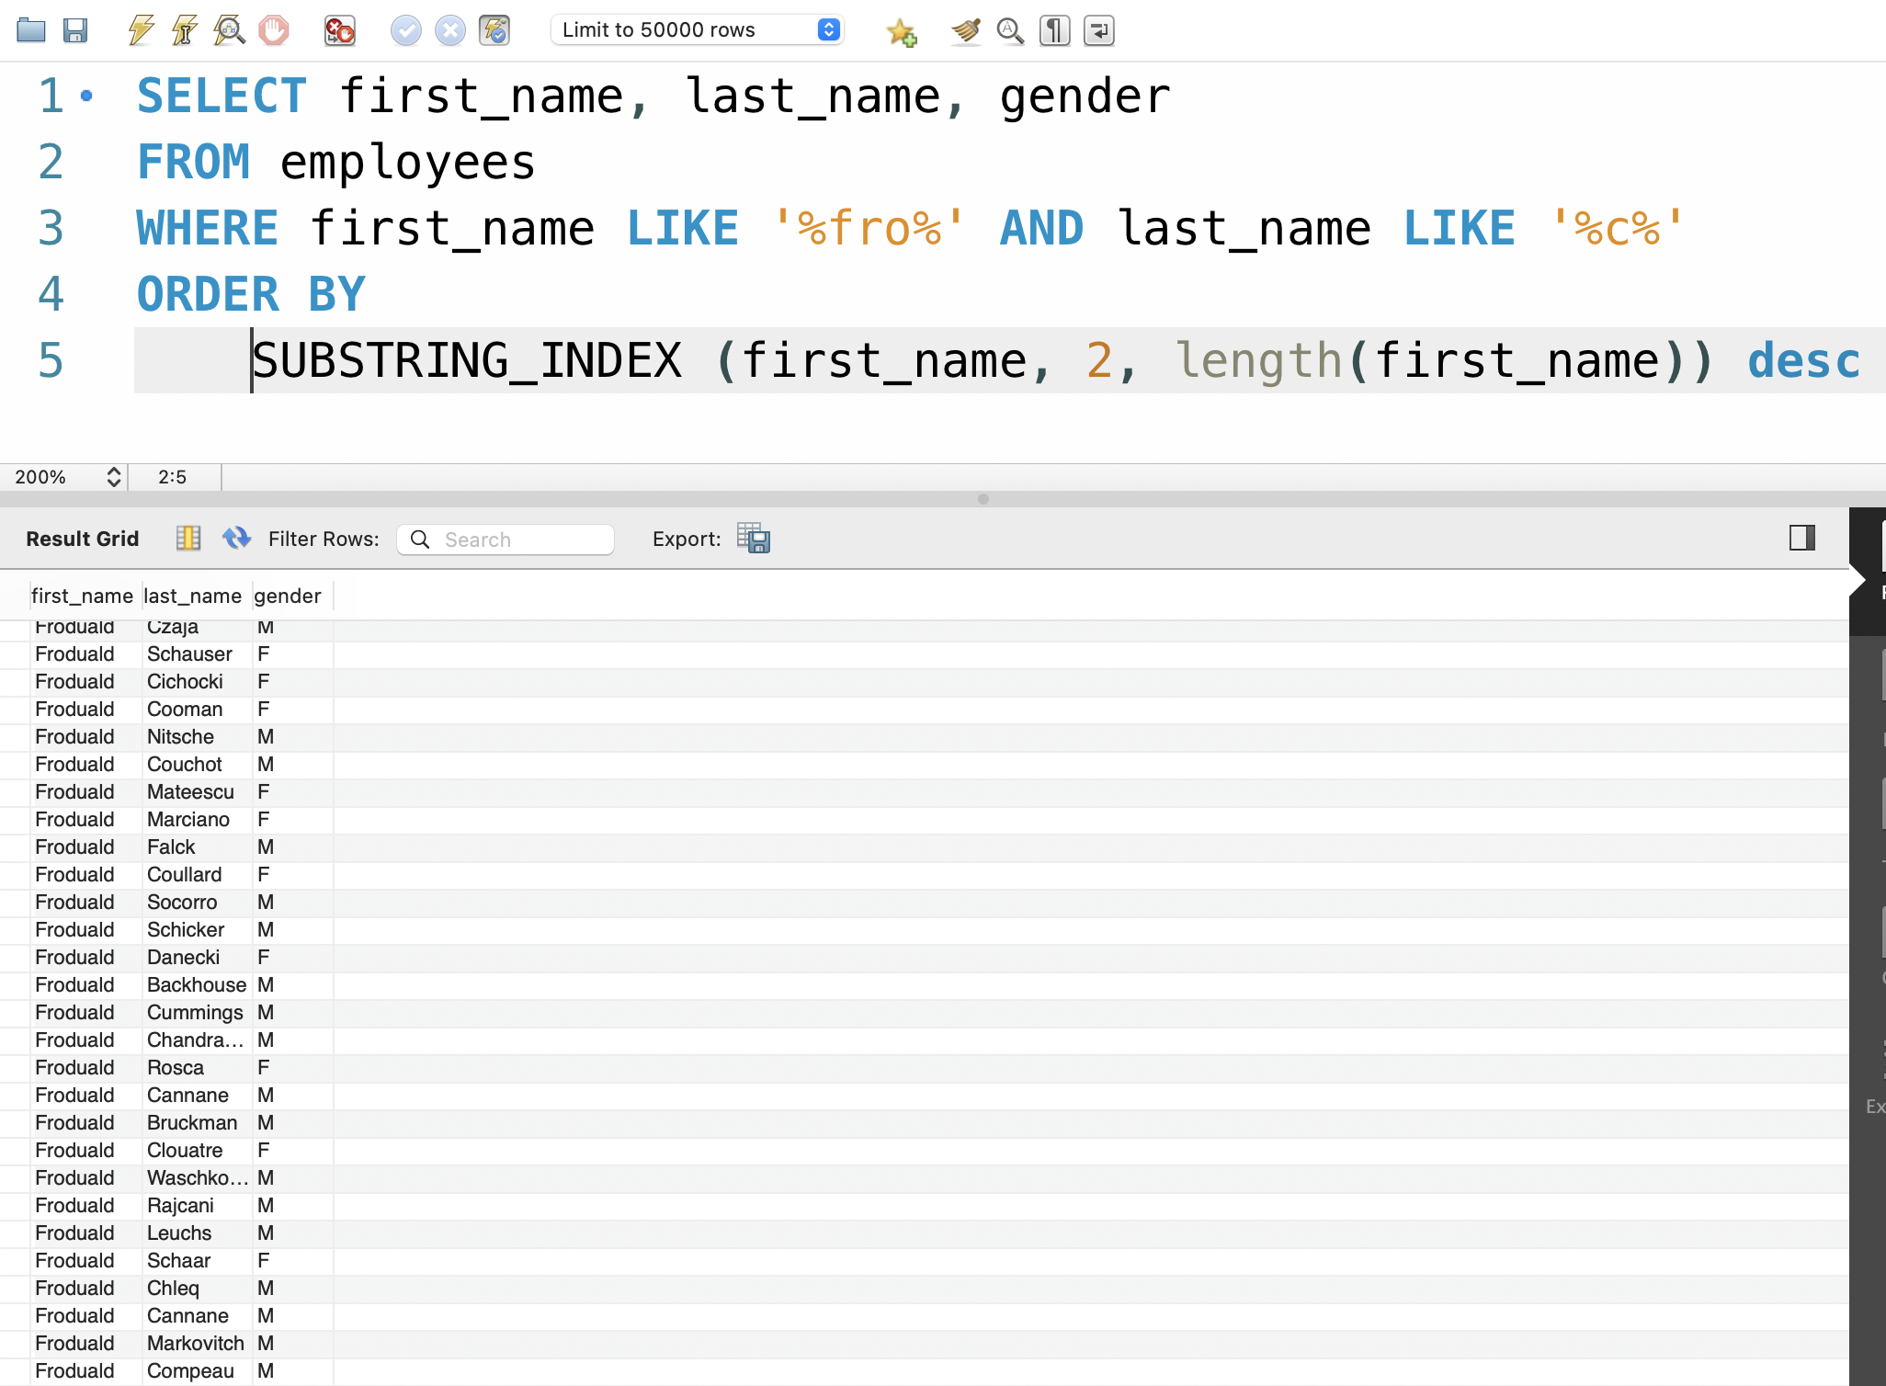

1. Displaying a list of employees and creating a column that will assign “Yes” if the gender column is null and “No” if the column is not null. Sorted the list by the is_null column in descending order and last name in ascending order.

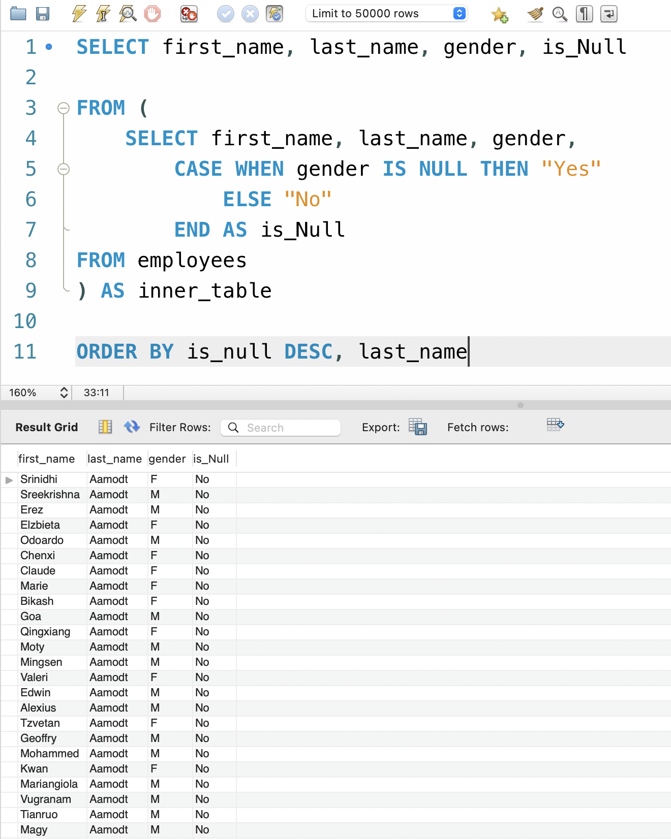

1. Display the employees table with a label on Male and Female employees and sort by the label column, then first name in ascending order and lastly the last name in descending order.

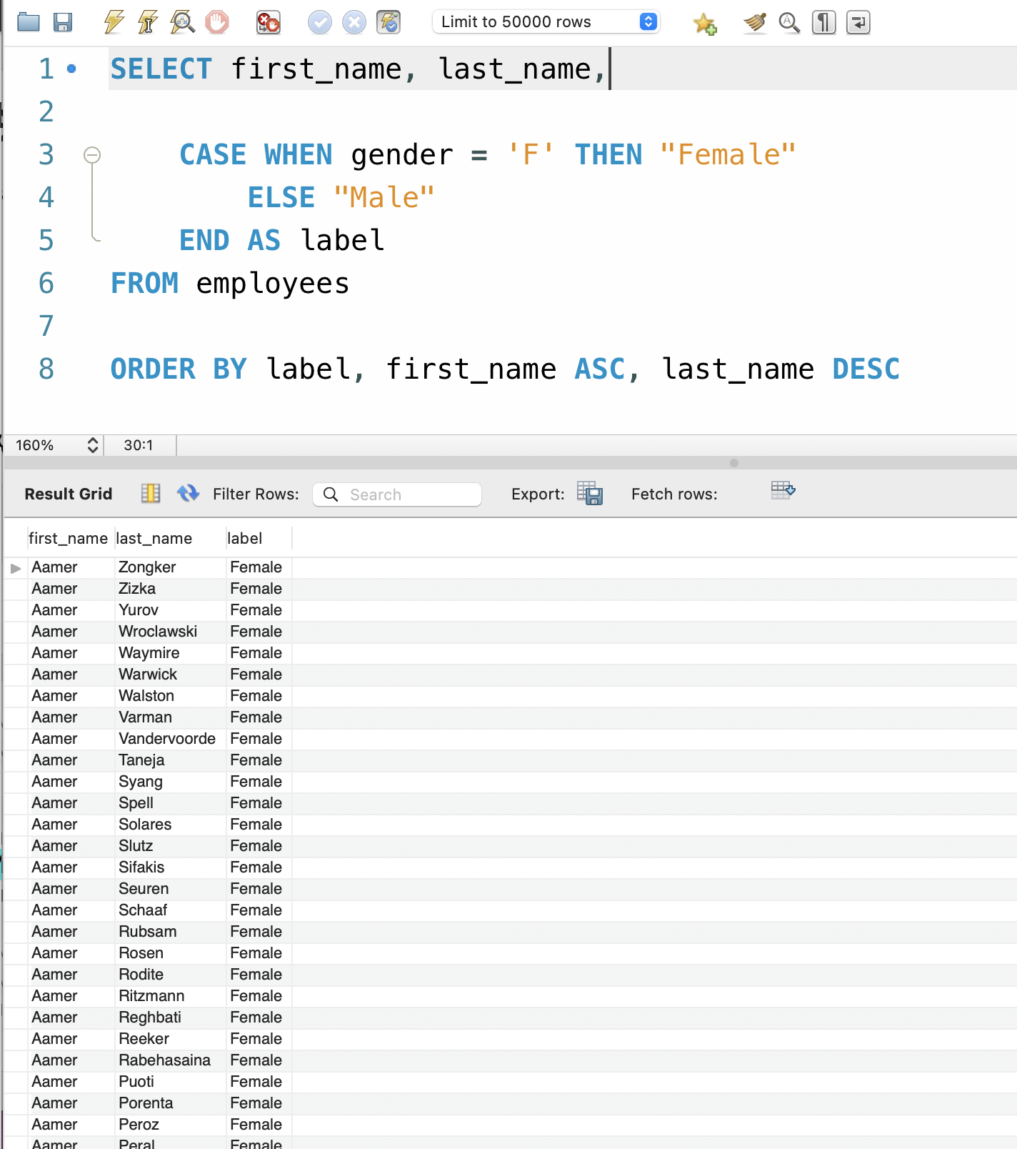

6. Displaying the list of male employees and the ages they were hired.

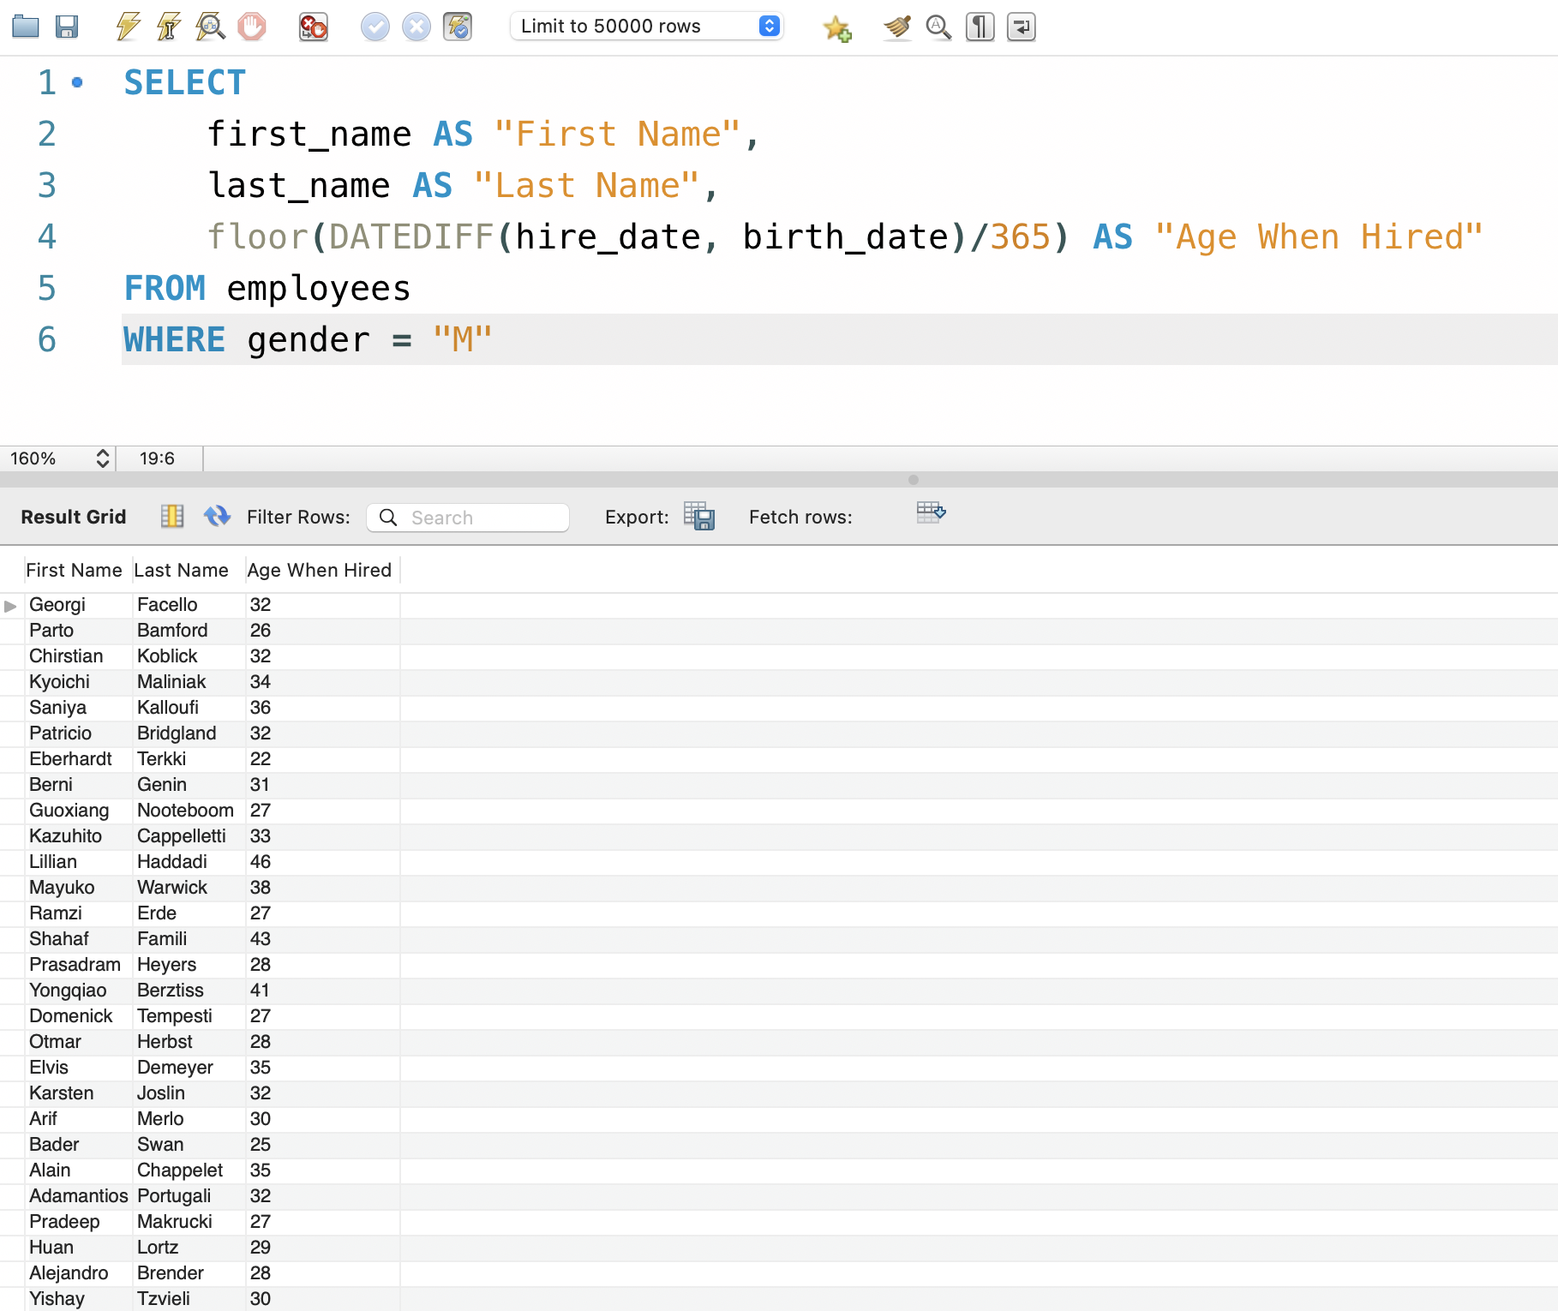

1. Using an inner table to create a list of female employees showing the ages they were hired.

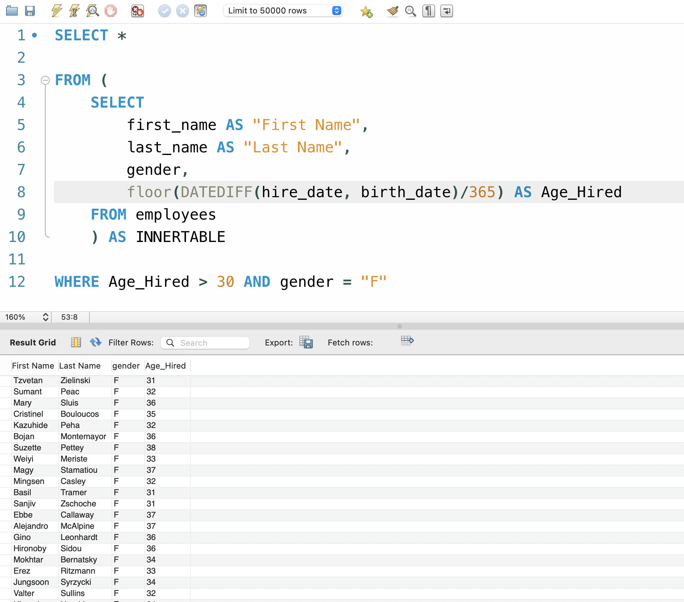

**PART III**

1. Union the titles and dept_emp tables.

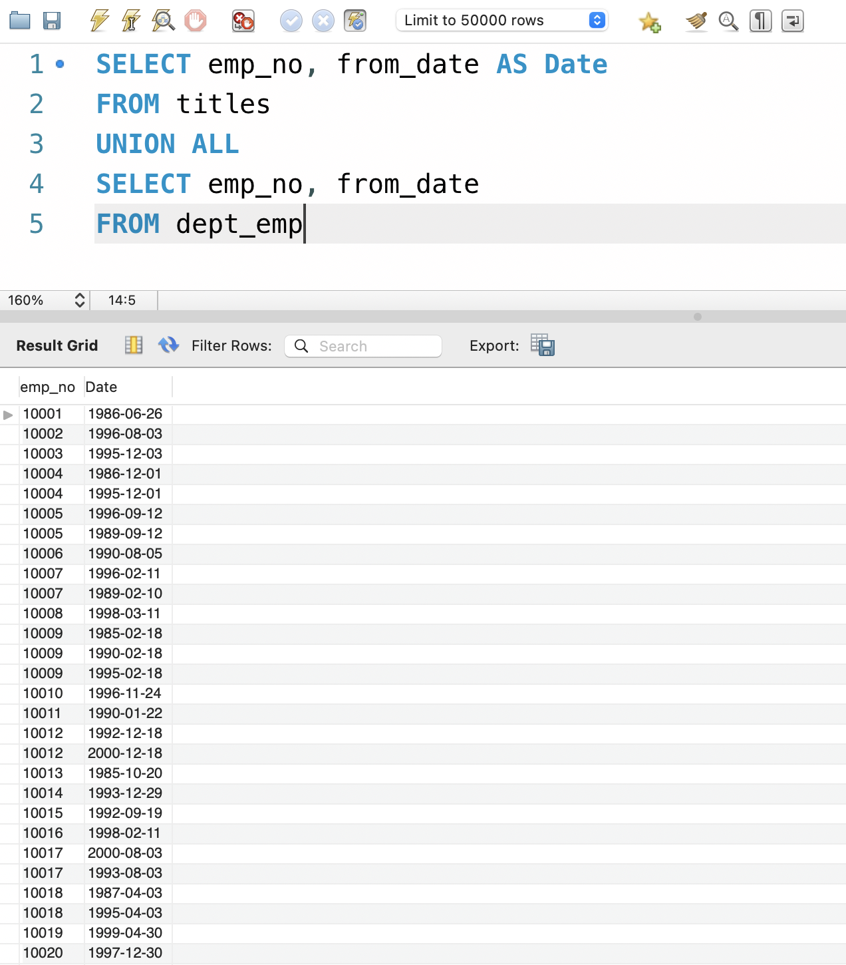

1. Join the employees and title tables to produce a report of employees and their titles with the duration they had the titles

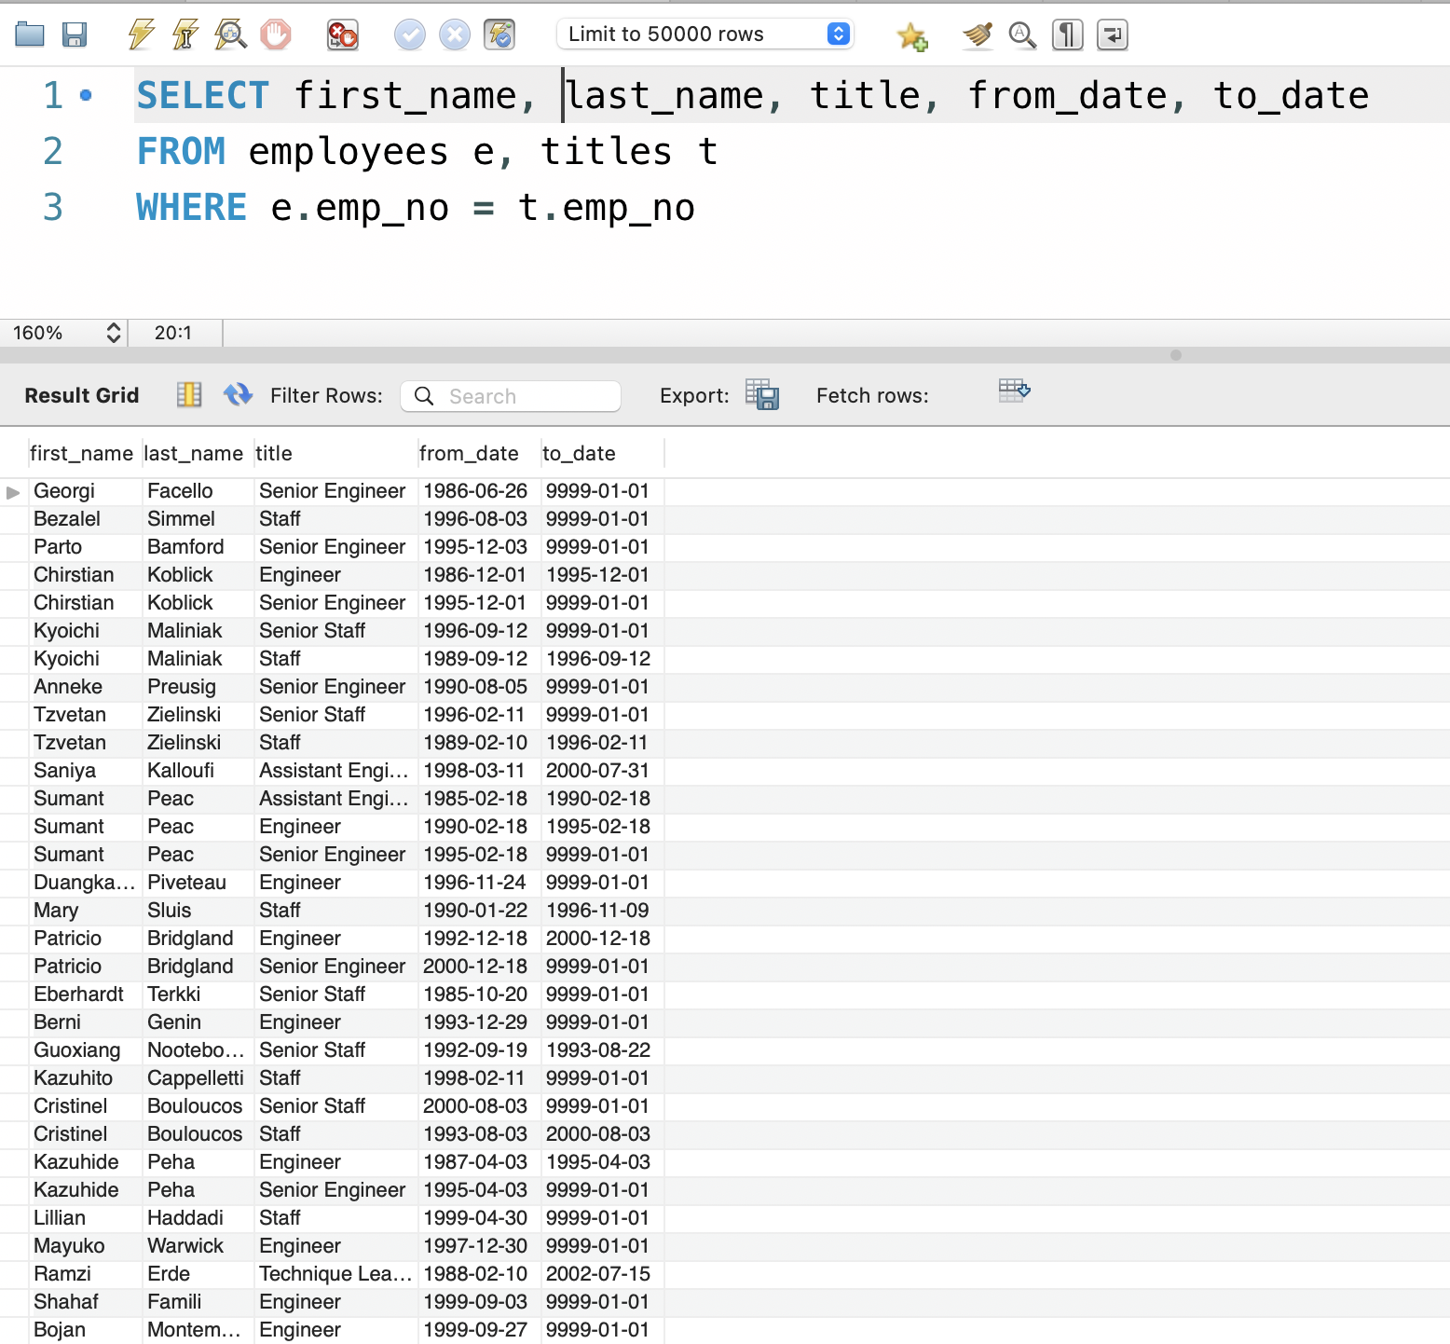

1. A report to show the list of employees without a title. The table is empty meaning all employees have a title.

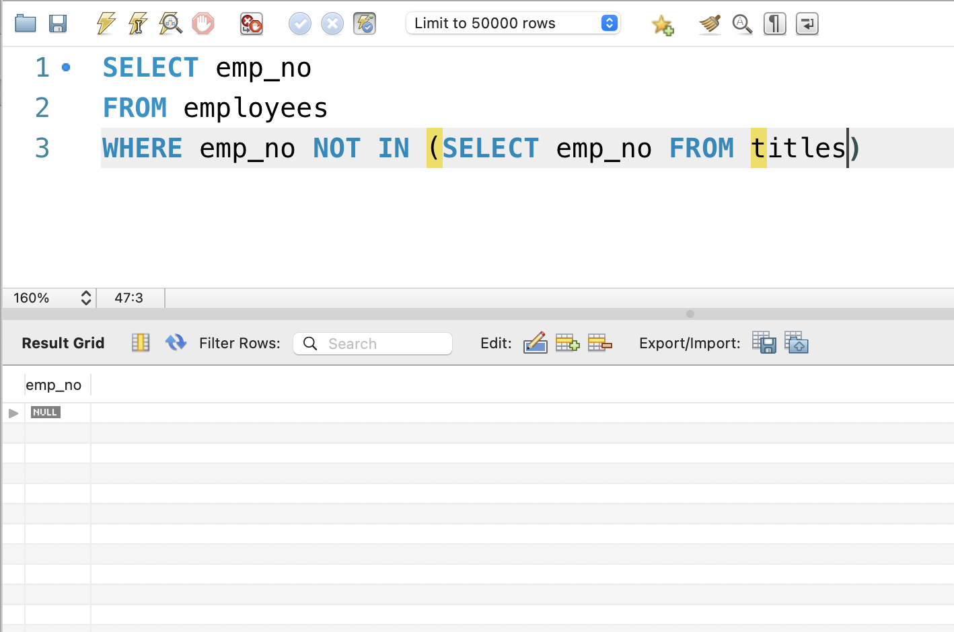

1. Get the total number of female employees, the sum and average of their salaries.

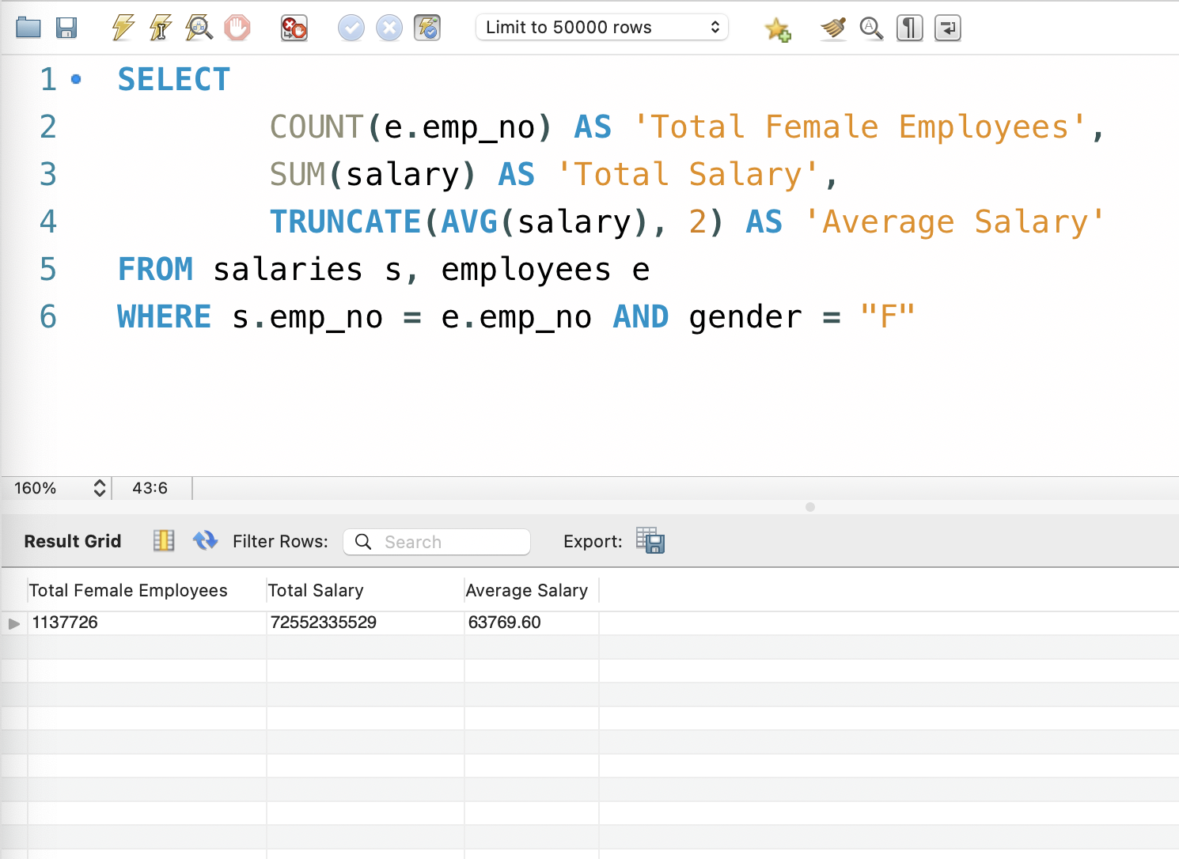

**PART IV**

1. Inserting a new row to the department table.

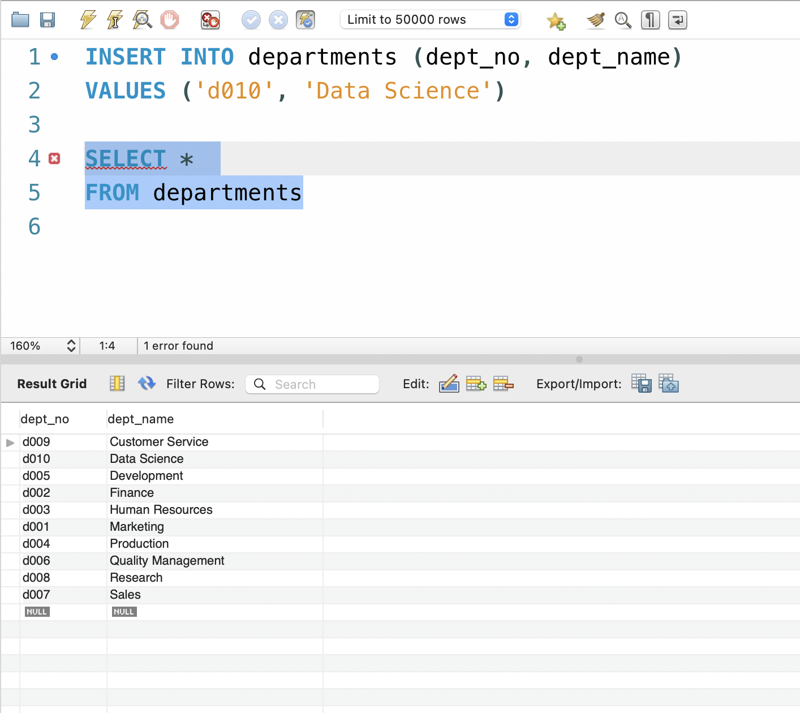

1. Create a Managements table and insert multiple rows into it.

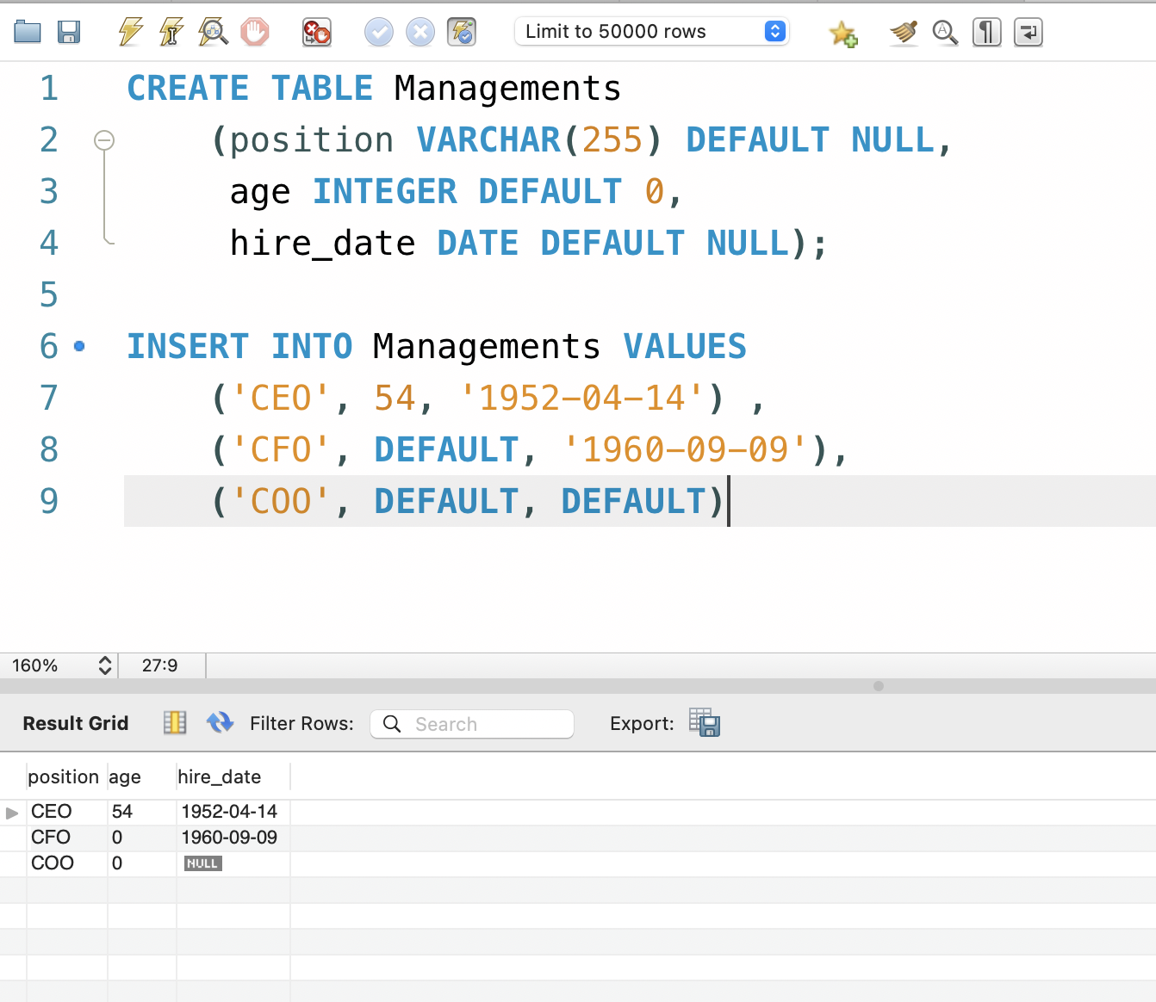

1. Create a Players table and insert columns overriding the default values.

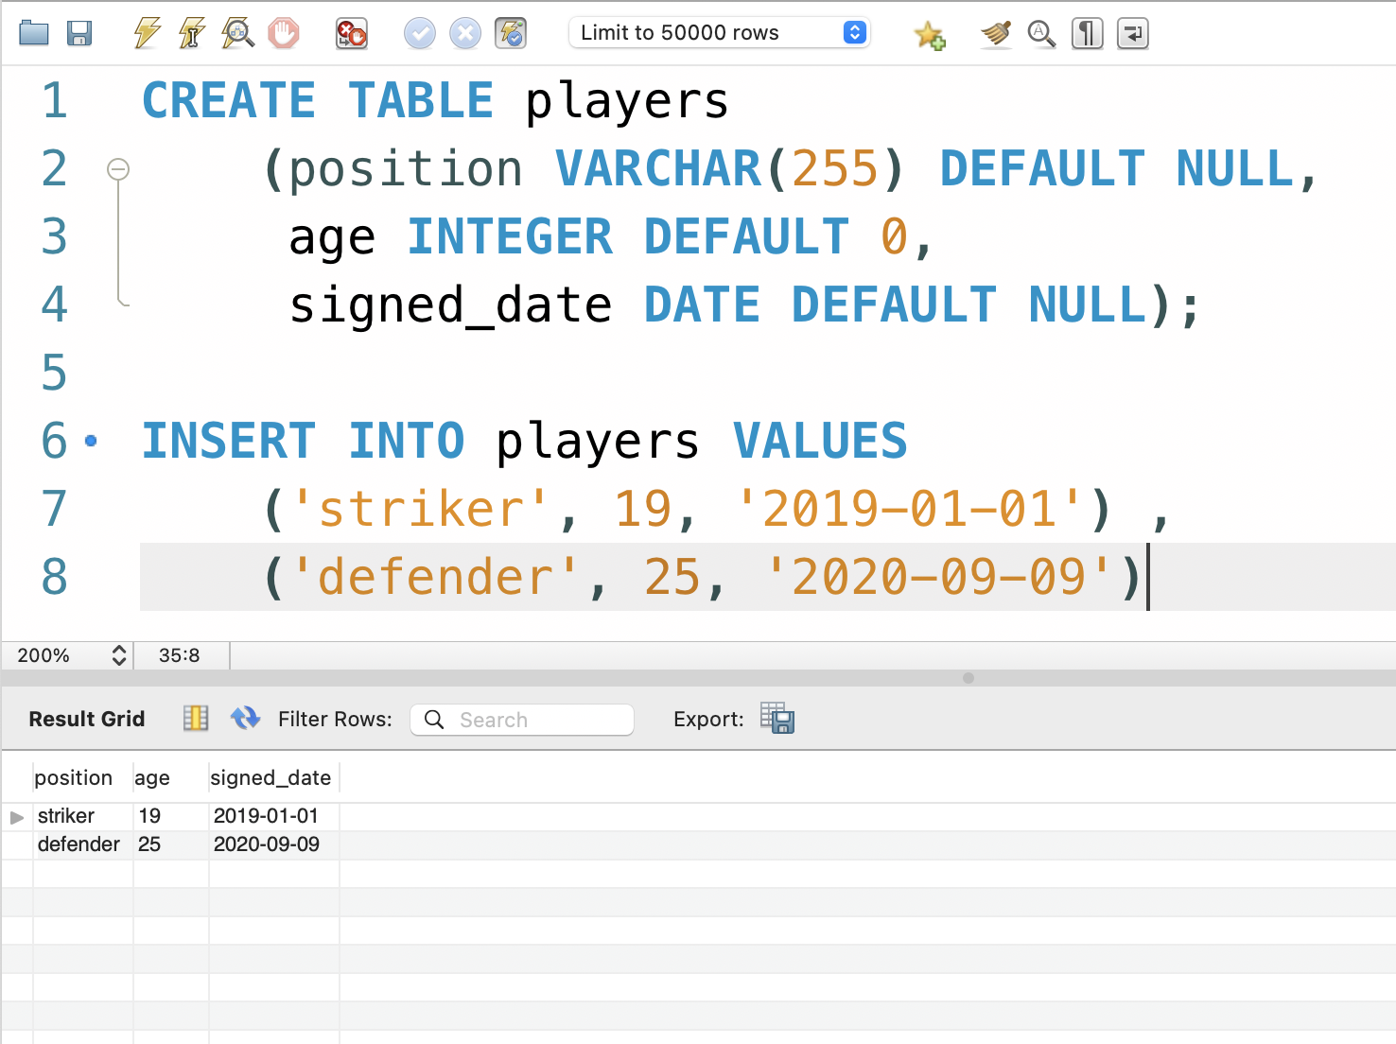

1. Copying rows from the Managements table into the Players table.

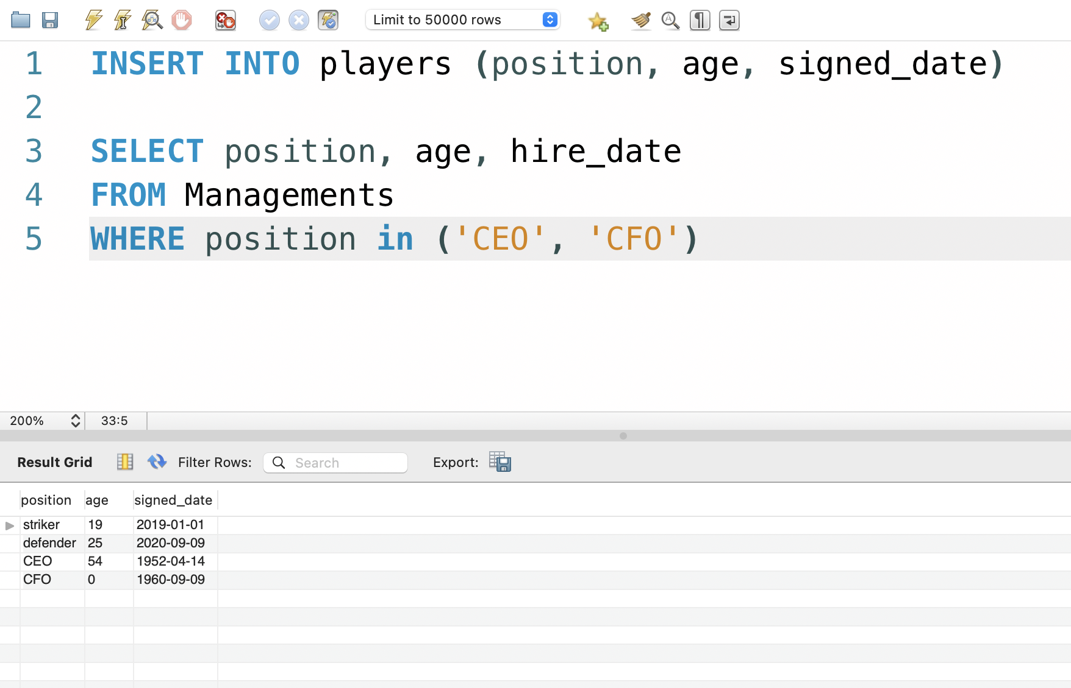

1. Creating a table named scouts using the column names of players but not the contents.

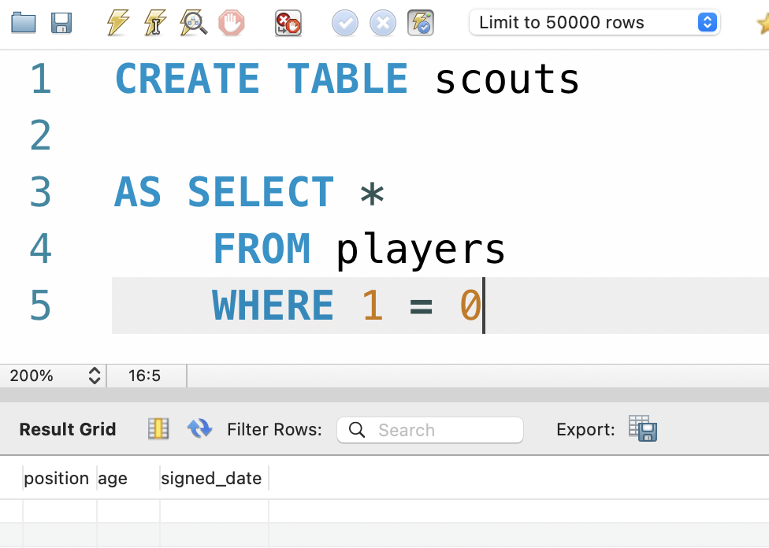

1. Increase the salary of employee with emp_no 10001 by 50%.

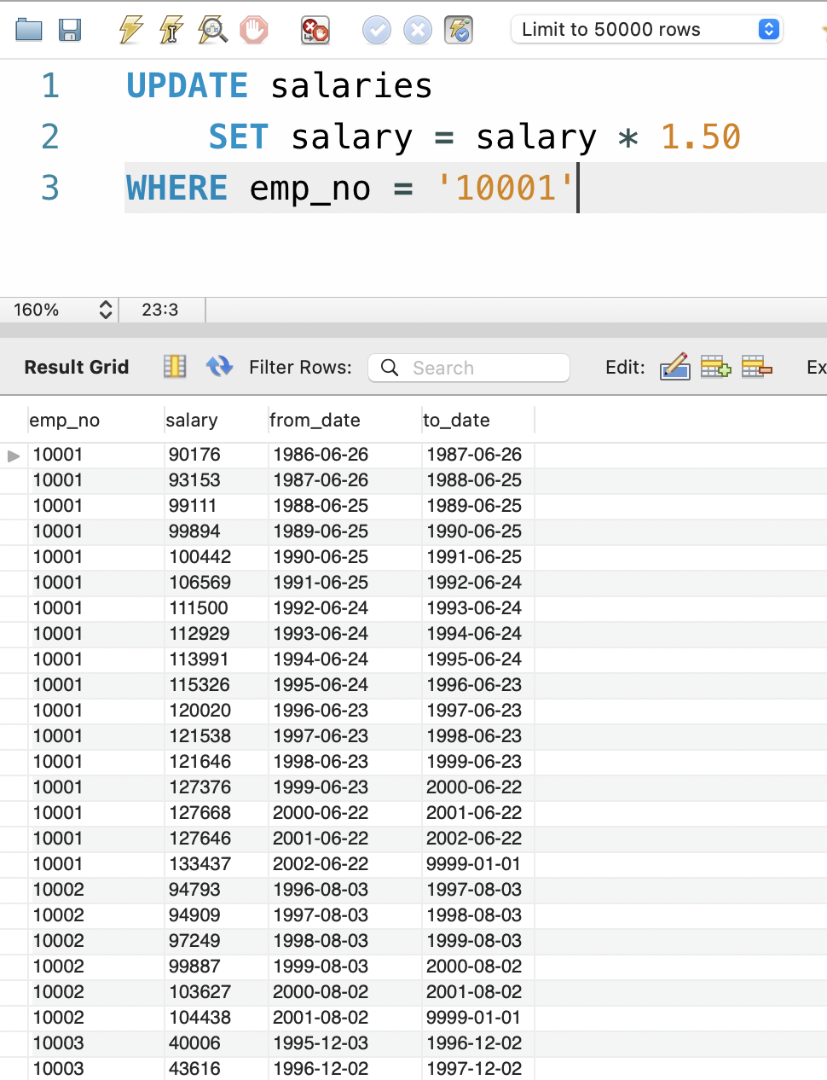

1. Update the salaries table by increasing the salaries of staff employed before January 1st, 1986 by 20%.

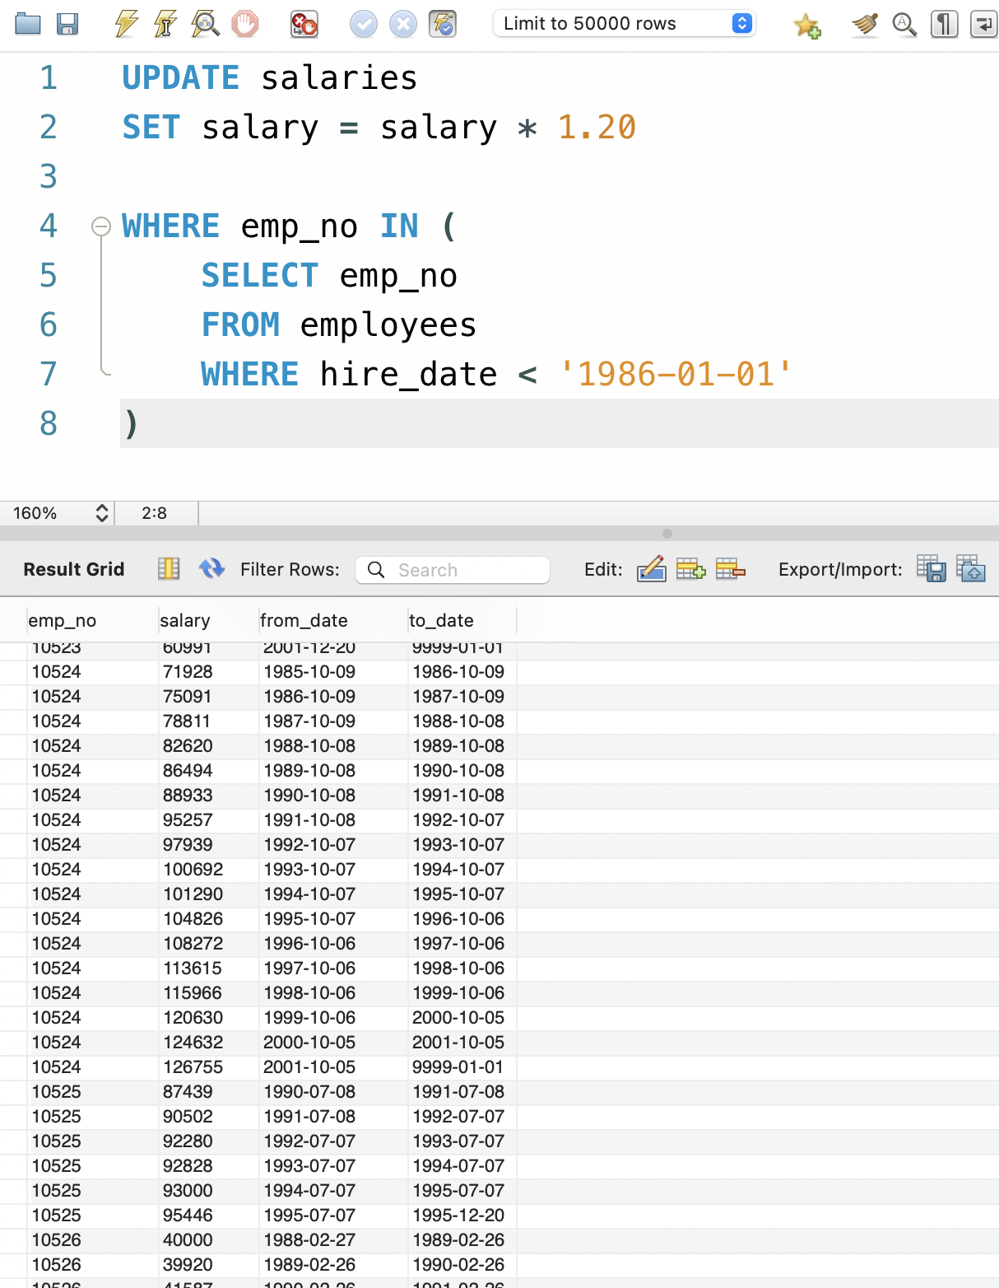

1. Delete specific rows from the departments table

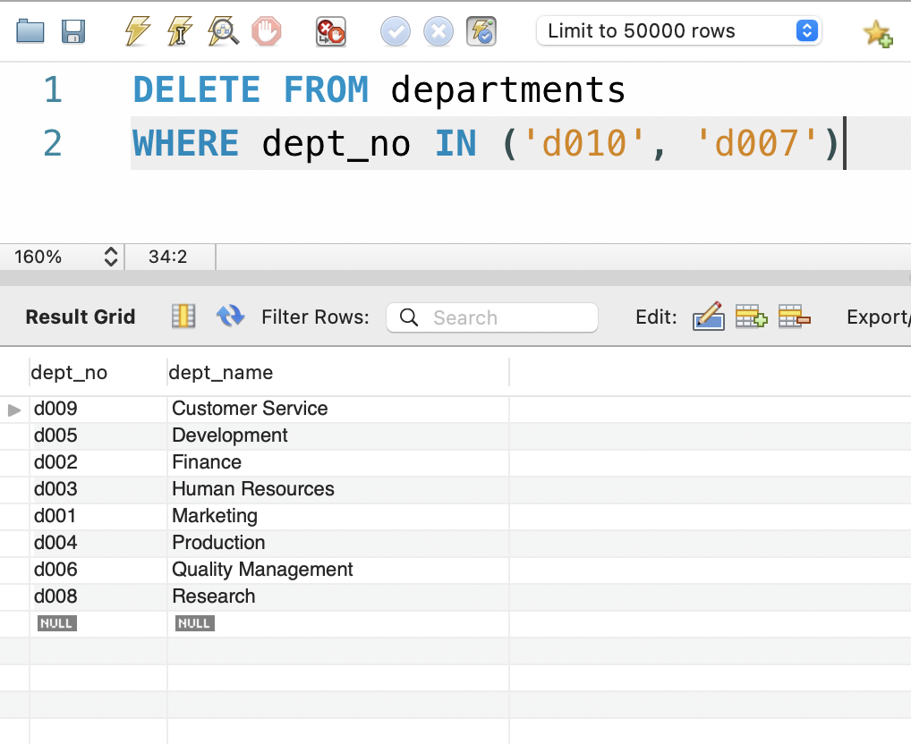

1. Delete rows in the Management table where the positions do not appear in the Players table. 1 row was deleted – (The row that contained the COO).

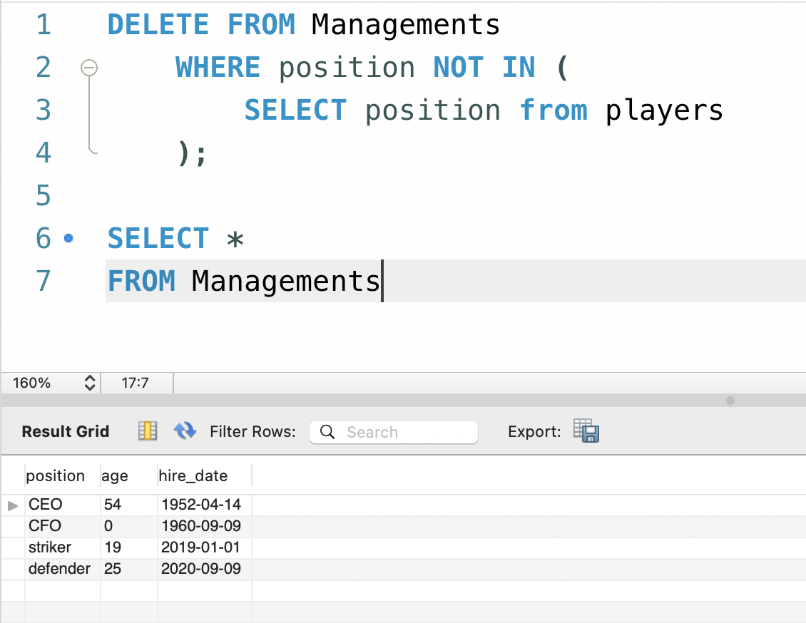

1. Delete duplicate records from the employees table.

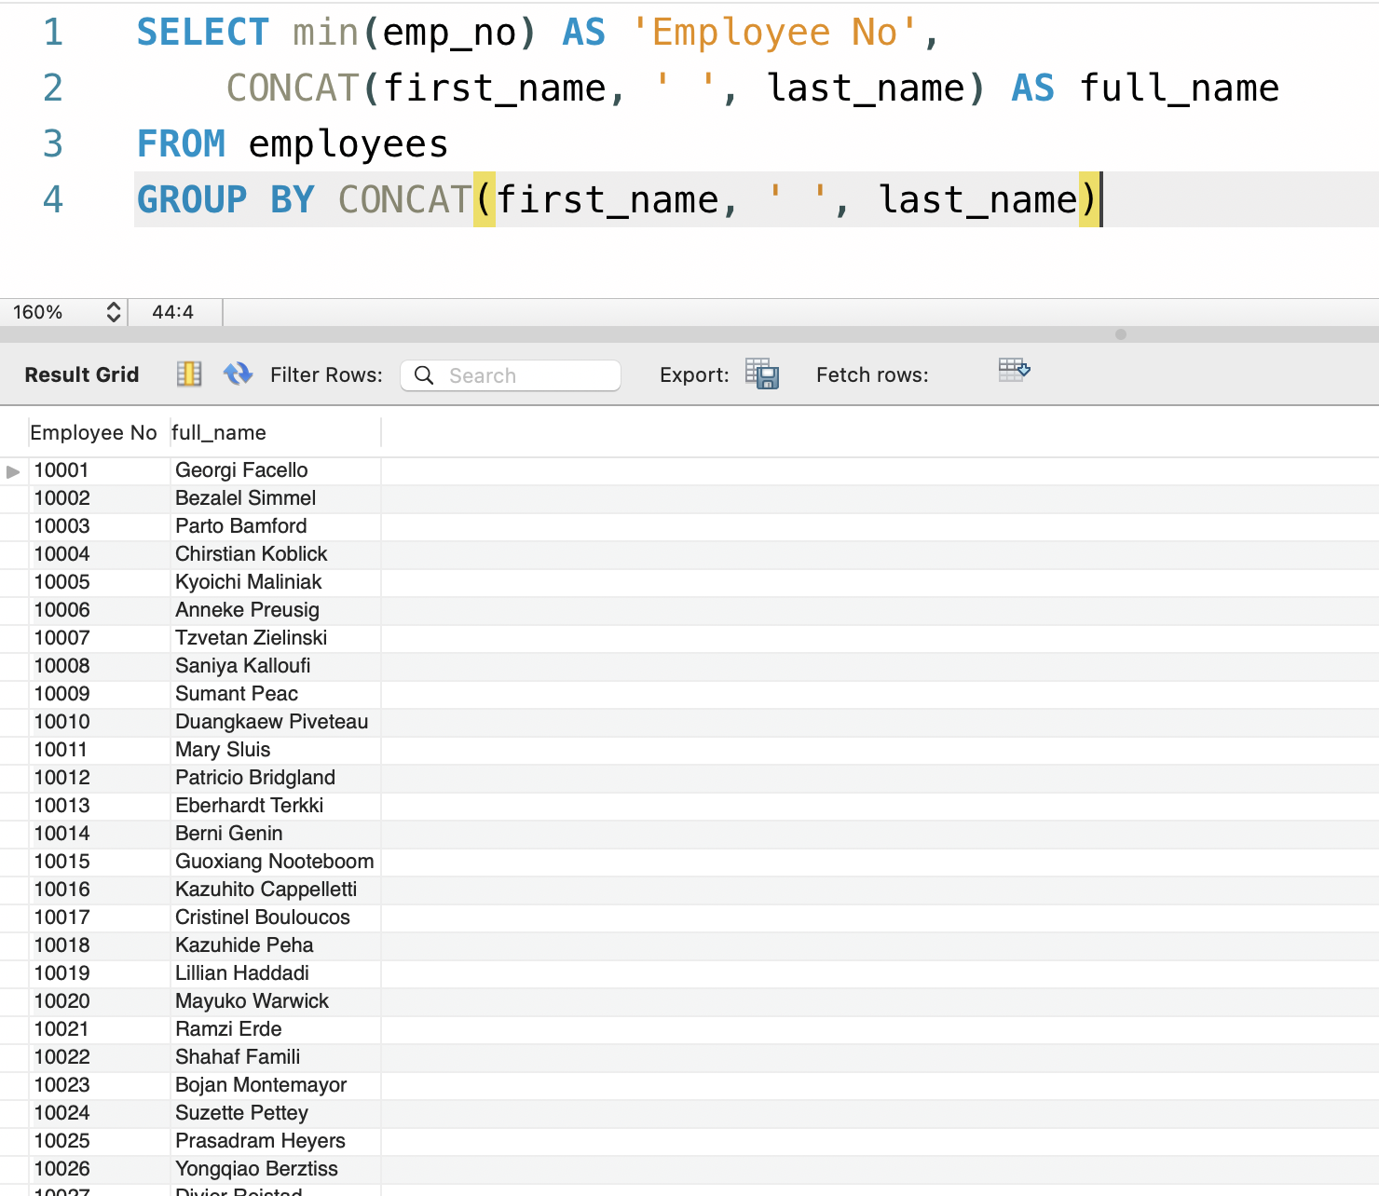

1. Delete from the employees table those that have worked for more than 1 department since they started working in the company.

